[Organisation] · PHASE B · TEMPLATE T-04
Business Architecture
Current state, target state, gaps, building blocks and blueprint for the Wave 1 cycle
Field | Detail
Version | 0.2 — Draft
Date | May 2027
Owner | Business Domain Architect
Approver | Architecture Board
Supersedes | Supersedes the separate Architecture Definition Document and Business Architecture Blueprint, which each carried current state, target state and the gaps. Holding one copy of those removes the only way the two could disagree.
Classification | Internal

Contents
1. Scope and viewpoints
2. Current state
3. Target state
4. Capability assessment
5. Value streams
6. Products, channels and the control cycle
7. Gaps
8. Architecture building blocks
9. The blueprint
10. Candidate roadmap
11. Stakeholder review
12. Open items
13. Findings
14. Approval

One document, one copy of every figure
This supersedes the separate Architecture Definition Document and Business Architecture Blueprint. Each carried its own account of current state, target state and the gaps, which is one copy too many. Gaps and work packages are read from metamodel O29 and O30; the eight Phase B artifacts hold the detail and are referenced, not restated.

1. Scope and viewpoints
 | Detail
In scope | [Organisation] Life, [Organisation] Short-Term, [Organisation] Funeral, Group Operations, Group Technology, Group Data and Group Finance, per SAW-2027-01.
Out of scope | [Organisation] Namibia and [Organisation] Botswana, which are federated. Investments and Marketing & Brand, which have no architecture engagement.
Level of detail | Capabilities to level 3, value streams to stage, services to service level. Process detail belongs to the operating units and is not held here.
Time horizon | Baseline as at April 2027. Target as at December 2030, with the Wave 1 position at December 2028 called out separately.

1.1 Viewpoints used
Viewpoint | Artifact | Content | Principal stakeholder
Capability | Business Capability Map | 556 capabilities, 134 assessed at level 3 | Chief Executive, line of business Managing Directors
Value stream | Value Stream Definition | 7 streams, 38 stages | Chief Operating Officer, Claims and Distribution executives
Organisation | Organisation Map and Chart | 23 map nodes, 102 positions | Group HR Director, Chief Information Officer
Service and function | Business Service and Function Catalog | 20 services, 12 functions | Line of business Managing Directors
Actor and role | Actor and Role Catalogue | 18 actors, 18 roles | Group HR Director
Information | Information Map | 24 concepts, 11 subject areas | Chief Data Officer
Customer experience | Customer Journey Map | 7 phases, 5 moments of truth | Chief Operating Officer, Chief Distribution Officer
Process | Process Modelling Convention | 3 worked BPMN examples | Operating unit heads

2. Current state
As at April 2027, including what works.

Domain | Position | What it means
Capabilities | 556 capabilities, 134 assessed at level 3. Weighted mean maturity 2.51 against a target of 3.90. | 76 of 134 are Critical and 47 High. Six Critical capabilities sit at maturity 1.
Value streams | Seven streams, 38 stages. Thirteen stages carry no measure at all. | The two streams measured at every stage, Acquire Cover and Settle a Claim, are the two that have been automated. The other five are unmeasured because nothing records them.
Organisation | 23 nodes: 4 lines of business, 7 functions, 3 collaborative teams, 8 partners. 102 positions. | Five nodes appear in no recorded interaction, including a whole line of business and all three collaborative teams.
Services and functions | 20 business services and 12 business functions. | Seven services are not channel agnostic, and all seven are customer-facing. Only two services currently meet their service level.
Actors and roles | 18 actors and 18 roles. | Eight roles have no actor recorded as performing them, including Data Owner. Ten actors hold no role, correctly, and all ten are external.
Information | 24 information concepts across 11 subject areas. | 23 concepts are owned by a role no actor performs. Three have a contested authoritative source; one has none at all.
Products | 18 products, 2.55 million policies in force, R37.8bn of product gross written premium. | Nine of 18 are coded rather than configured, which is why product configuration takes 120 days.
Customer experience | One mapped journey, seven phases, five moments of truth. | Two phases sit outside every value stream. The emotional low point is the 48-hour claim promise, delivered at an eleven-day median.

3. Target state
The same structure, with the difference stated rather than the whole described again.

Domain | Target | How it differs
Capabilities | Weighted mean maturity 3.0 by December 2028 and 3.9 by 2030. | 43 capabilities marked Invest and 26 marked Build. Sustain and Optimise account for the remaining 64 and receive no funded change.
Value streams | Every stage measured, and the two stages that exist only because of the systems beneath them removed. | Settlement no longer waits for an overnight batch; product configuration is no longer a software release.
Organisation | Collaborative teams carry recorded flows, and every role has an actor. | Nine operational roles added to the catalogue under change request; the Data Owner role filled before identity work proceeds past G2.
Services and functions | Every customer-facing service channel agnostic. | The seven that are not become one service each, rather than one implementation per channel.
Information | Every concept owned by a role somebody performs, and every authoritative source designated. | The Data Governance Council designates sources before the identity hub is built on them.
Products | Rating and product configuration held outside the policy administration platform. | Configuration falls from 120 days to 30. The coded nine migrate to configuration as their platforms allow.
Customer experience | The claim promise is met, and the journey does not end in silence. | Funeral settlement at two days. A closing contact after every claim, owned by a named role.

4. Capability assessment
Measure | Position
Capabilities assessed | 134 of 556, at level 3
Weighted mean maturity | 2.51 current against 3.90 target
Criticality | 76 Critical, 47 High, 11 Medium
Disposition | 60 Sustain, 43 Invest, 26 Build, 4 Optimise, 1 Outsource
Differentiation | 24 Differentiating, 25 Advantage, 49 Parity, 36 Commodity
Critical capabilities at maturity 1 | 6
Capabilities with no maturity gap | 26

Sixty-four capabilities receive no funded change
Sixty Sustain and four Optimise. Stating what will not be invested in is as much a part of the target as stating what will, and it is the part most likely to be quietly reversed when the roadmap meets the budget.

5. Value streams
Seven streams, 38 stages. Thirteen stages carry no measure, and all thirteen sit in the five streams not yet automated.
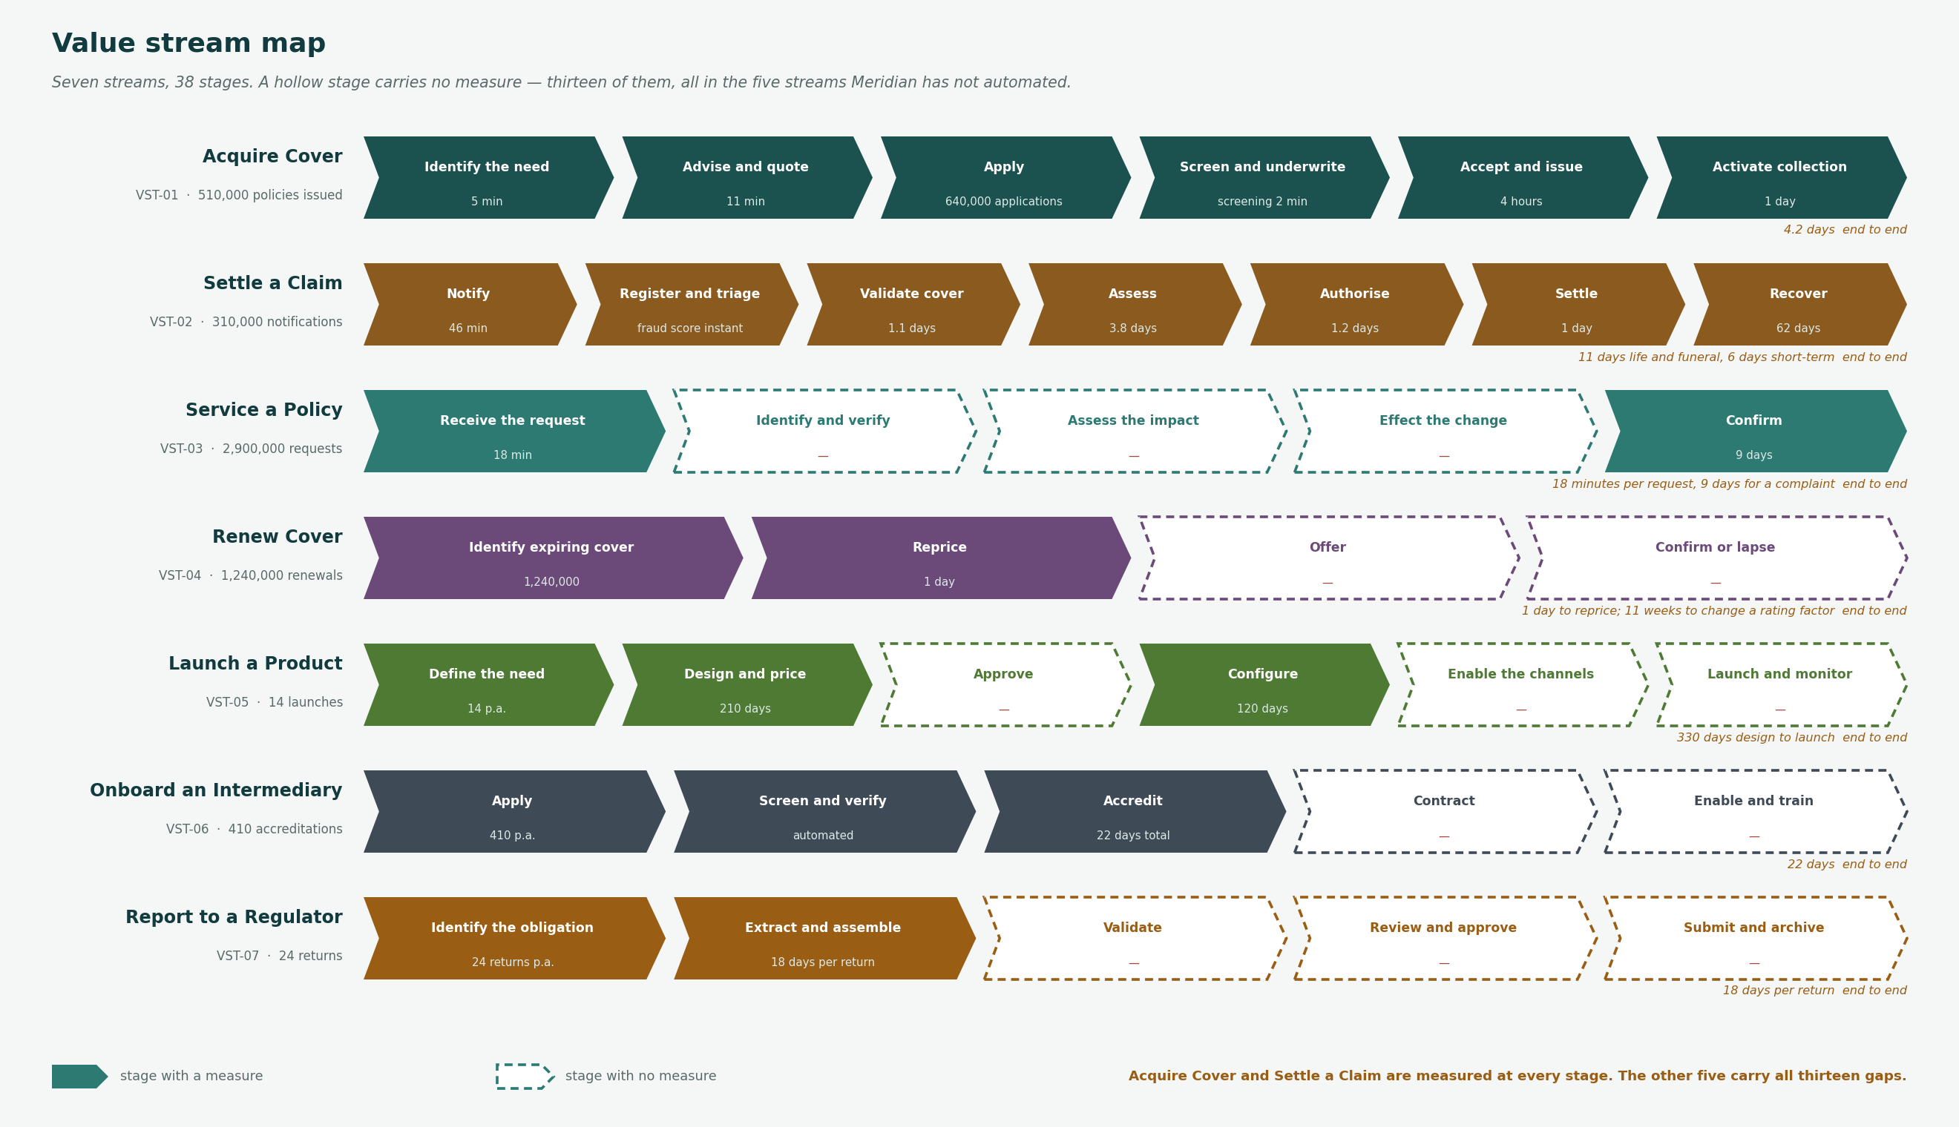
Figure 1 — The seven value streams. A hollow stage carries no measure.

6. Products, channels and the control cycle

6.1 Product architecture
Measure | Position
Products in force | 18, of which 17 in market and 1 in pilot
Policies in force | 2,545,910
Product gross written premium | R37.8bn
Configuration model | 9 configured, 9 coded
Consequence | Product configuration takes 120 days because a coded product change is a platform release

6.2 Channel and intermediary model
Incomplete. The metamodel holds no channel object, so channel economics, volume and persistency are not available at the level template T-04 asks for.
What is known: distribution runs through tied agency, independent brokers, bancassurance, direct and embedded partners. Broker-placed business is the largest channel by premium. Quote-to-issue is 31% digital across all channels and materially lower for commercial.

6.3 Actuarial control cycle
Incomplete for the same reason. The Actuarial Control Cycle diagram is a Phase B artifact that has not been built.
What is known: pricing basis, experience analysis, assumption setting and reserving sit with Group Finance and Actuarial, 64 actuaries. Experience monitoring is quarterly and manual, and product design takes 210 days against a pricing cycle that should inform it.

7. Gaps
Eighteen, read from metamodel O29. Every one is addressed by a work package from O30. Nothing in this table was authored for this document.

Ref | Gap | Domain | Type | Severity | Addressed by
GAP-01 | No single customer identity | Data | New | Critical | WP-04 Customer Master Data Management
GAP-02 | No customer timeline | Data | New | Critical | WP-05 Customer Timeline & Conduct Evidence
GAP-03 | No enterprise data platform | Data | New | High | WP-06 Enterprise Data Platform
GAP-04 | No data ownership register | Data | New | High | WP-03 Data Governance Foundation
GAP-05 | Product configuration hard-coded | Application | New | Critical | WP-08 Product Configuration Platform
GAP-06 | No managed integration layer | Application | New | Critical | WP-02 Integration Platform Foundation
GAP-07 | Channel-specific quotation | Application | New | High | WP-07 Channel-Agnostic Quotation
GAP-08 | Broker portal not fit for purpose | Application | Replace | High | WP-09 Intermediary Experience Replacement
GAP-09 | Manual life claims notification | Application | New | High | WP-10 Claims Modernisation
GAP-10 | Two claims systems | Application | Eliminate | Medium | WP-10 Claims Modernisation
GAP-11 | No model governance | Application | New | High | WP-12 Model Governance
GAP-12 | Spreadsheet regulatory assembly | Data | Eliminate | High | WP-06 Enterprise Data Platform
GAP-13 | No architecture repository | Realization | New | Critical | WP-01 Establish Architecture Governance
GAP-14 | No architecture governance forum | Realization | New | Critical | WP-01 Establish Architecture Governance
GAP-15 | Contained technology past support | Technology | Replace | High | WP-11 Technology Currency & Resilience
GAP-16 | Untested resilience tiers | Technology | New | High | WP-11 Technology Currency & Resilience
GAP-17 | Generic accounts on legacy | Technology | Eliminate | High | WP-13 Access Control Remediation
GAP-18 | No climate exposure integration | Data | New | Medium | WP-14 Climate Exposure Integration

8. Architecture building blocks
A package of capability, defined by what it must do and not by what will do it.

Question | Answer
What an architecture building block is | A package of capability, defined by what it must do and not by what will do it. Technology and product neutral.
What it is not | A system, a vendor, a project or an application. Those are solution building blocks, and they are chosen in Phase C and later.
Why the distinction matters | A building block outlives the product that realises it. Naming a product here forecloses the standards assessment and dates the architecture.
How one is written | A name, what it must do, the capabilities it realises, its dependencies, and the criteria a solution must meet to be accepted as realising it.
Where it sits in the metamodel | Nowhere. O21 holds Logical Data Components and O26 Logical Technology Components; there is no business equivalent. Raised as CR-025.

8.1 The building blocks
Ref | Building block | What it must do | Capabilities realised | Depends on | Gap | Package | Wave
ABB-01 | Party Identity Resolution | Resolve any presented party to one enterprise identity across all masters, without replacing any master. | C02.01 Customer Identity & Data | — | GAP-01 | WP-04 | Wave 2
ABB-02 | Party Timeline | Assemble every interaction with a party — advice, policy, claim, complaint — into one ordered view. | C02.02 Customer Insight, C10.02 Regulatory Compliance | ABB-01 | GAP-02 | WP-05 | Wave 2
ABB-03 | Data Ownership and Stewardship | Hold, for every information concept, a named accountable owner and a designated authoritative source. | C11.01 Data Governance | — | GAP-04 | WP-03 | Wave 1
ABB-04 | Managed Integration | Provide the single route by which applications exchange data, authenticated, logged and versioned. | C12.02 Technology Management | — | GAP-06 | WP-02 | Wave 1
ABB-05 | Product Definition and Configuration | Hold product definitions, rating factors and rules as configuration, changeable without a platform release. | C01.02 Product Development, C01.03 Product Lifecycle Management | ABB-04 | GAP-05 | WP-08 | Wave 2
ABB-06 | Channel-Agnostic Quotation | Price and quote a risk identically regardless of the channel the request arrives through. | C03.04 Advice & Sales, C04.01 Risk Assessment | ABB-05, ABB-04 | GAP-07 | WP-07 | Wave 2
ABB-07 | Intermediary Submission and Servicing | Accept business from an intermediary through the interface they already use, and show them its status. | C03.02 Intermediary Management, C03.03 Digital & Embedded Distribution | ABB-06, ABB-04 | GAP-08 | WP-09 | Wave 3
ABB-08 | Claim Intake | Capture a claim once, at source, from any notifying party including an external one. | C07.01 Claim Notification | ABB-01 | GAP-09 | WP-10 | Wave 2
ABB-09 | Claim Assessment and Settlement | Assess, authorise and settle a claim with the party's full history in view, and pay on authorisation. | C07.02 Claim Assessment, C07.03 Claim Settlement | ABB-08, ABB-02 | GAP-10 | WP-10 | Wave 2
ABB-10 | Analytical Data Platform | Hold governed analytical data with lineage from source to report. | C11.02 Data Integration & Lineage, C11.03 Analytics & Insight | ABB-03, ABB-04 | GAP-03 | WP-06 | Wave 2
ABB-11 | Regulatory Reporting Assembly | Assemble, validate and lodge a regulatory return from governed data without spreadsheet steps. | C10.02 Regulatory Compliance, C09.04 Financial Reporting | ABB-10 | GAP-12 | WP-16 | Wave 3
ABB-12 | Model Governance | Register, monitor and explain every model that influences a customer or capital outcome. | C10.04 Model & Data Risk | ABB-10 | GAP-11 | WP-12 | Wave 2
ABB-13 | Architecture Governance | Provide a body able to approve or refuse a design, and a repository that records what was decided. | C12.05 Enterprise Architecture | — | GAP-13, GAP-14 | WP-01 | Wave 1
ABB-14 | Resilience and Recovery | Establish and test recovery for every Tier 1 capability against a stated objective. | C12.02 Technology Management | — | GAP-16 | WP-11 | Wave 3

8.2 Acceptance criteria
What a solution must demonstrate to be accepted as realising the block. This is what a solution architect is held to at G2.

Ref | Building block | A solution is accepted when
ABB-01 | Party Identity Resolution | Resolves 95% of presented parties in under 2 seconds; never auto-merges below a stated confidence; queues the remainder for a steward.
ABB-02 | Party Timeline | Assembles a complete timeline for any resolved party without manual collation; evidences a conduct outcome from source.
ABB-03 | Data Ownership and Stewardship | No concept without a named owner who exists; no concept with a contested source; disputes resolved within one Council cycle.
ABB-04 | Managed Integration | Every new interface routed through it; no direct database reads; every call attributable to a consumer.
ABB-05 | Product Definition and Configuration | A rating factor changes in under a week; a new product configured in 30 days; no product change requires a code deployment.
ABB-06 | Channel-Agnostic Quotation | Same risk, same price, any channel; indicative commercial quote in under 15 minutes; every quotation records an outcome.
ABB-07 | Intermediary Submission and Servicing | Submission by API without rekeying; existing file route maintained during transition; status visible to the brokerage.
ABB-08 | Claim Intake | Notification captured once with no rekeying; parlour network served by one route; claim created with policy and party resolved.
ABB-09 | Claim Assessment and Settlement | Prior claims across all lines visible at assessment; authorisation without leaving the claim; payment instructed on authorisation, not on batch.
ABB-10 | Analytical Data Platform | Every reported figure traceable to its source; no departmental mart holding an authoritative copy; lineage produced without manual assembly.
ABB-11 | Regulatory Reporting Assembly | No manual spreadsheet step between source and return; reconciliation breaks attributable; submission evidence retained in one place.
ABB-12 | Model Governance | No model in production without a register entry, an owner and monitoring; explainability proportionate to the outcome influenced.
ABB-13 | Architecture Governance | A design can be refused and the refusal recorded; every decision has a record; drift against baseline is detectable.
ABB-14 | Resilience and Recovery | Every Tier 1 capability has a tested RTO and RPO within the last 12 months; test evidence retained.

9. The blueprint
Five layers. Customers at the top, foundation at the bottom, and everything between depending on what sits below it.
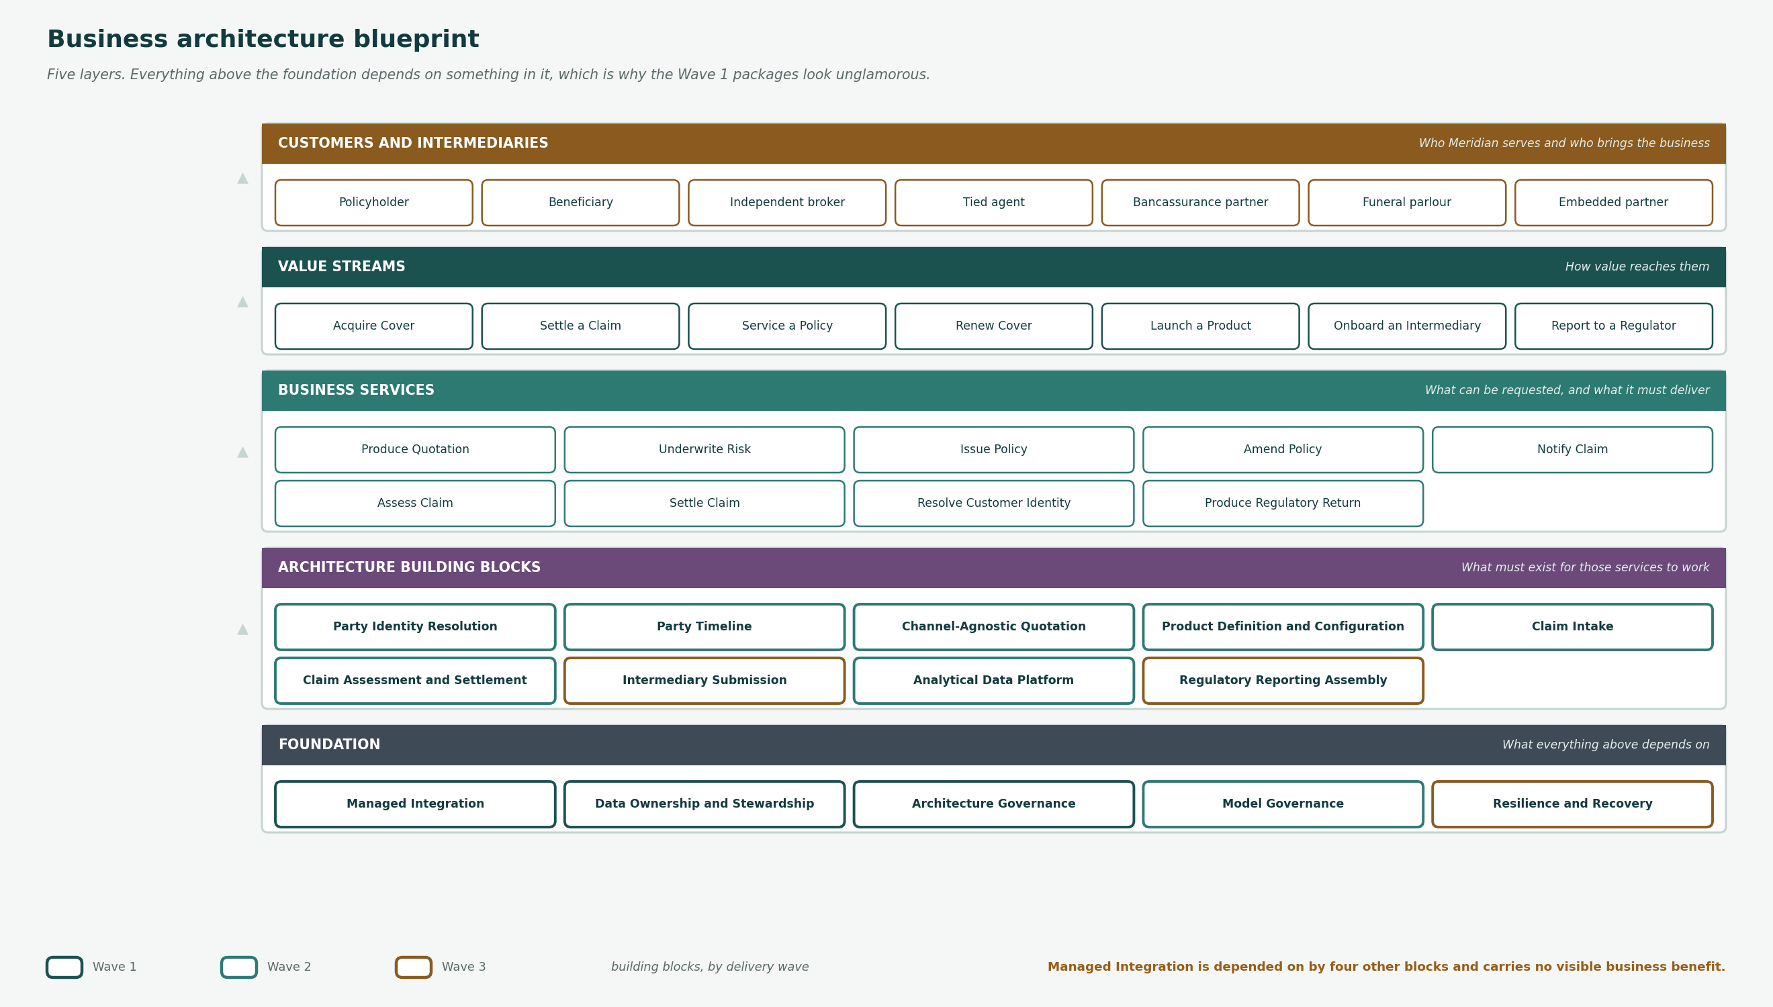
Figure 2 — The business architecture blueprint. Outlined blocks are building blocks, coloured by delivery wave.

Layer | What it holds | Why it is where it is
Customers and intermediaries | Policyholder · Beneficiary · Independent broker · Tied agent · Bancassurance partner · Funeral parlour · Embedded partner | Who [Organisation] serves and who brings the business
Value streams | Acquire Cover · Settle a Claim · Service a Policy · Renew Cover · Launch a Product · Onboard an Intermediary · Report to a Regulator | How value reaches them
Business services | Produce Quotation · Underwrite Risk · Issue Policy · Amend Policy · Notify Claim · Assess Claim · Settle Claim · Resolve Customer Identity · Produce Regulatory Return | What can be requested, and what it must deliver
Architecture building blocks | Party Identity Resolution · Party Timeline · Channel-Agnostic Quotation · Product Definition and Configuration · Claim Intake · Claim Assessment and Settlement · Intermediary Submission · Analytical Data Platform · Regulatory Reporting Assembly | What must exist for those services to work
Foundation | Managed Integration · Data Ownership and Stewardship · Architecture Governance · Model Governance · Resilience and Recovery | What everything above depends on

10. Candidate roadmap
Sixteen work packages across three waves, from metamodel O30. R814m of cost against R375.6m a year of benefit. Sequencing within a wave is Phase E.

Ref | Work package | Wave | Cost Rm | Benefit Rm p.a. | Transition | Owner
WP-01 | Establish Architecture Governance | Wave 1 | 6.4 | 0 | TA-1 | Chief Enterprise Architect
WP-02 | Integration Platform Foundation | Wave 1 | 42.8 | 11.2 | TA-1 | Chief Information Officer
WP-03 | Data Governance Foundation | Wave 1 | 12.6 | 4.1 | TA-1 | Chief Data Officer
WP-04 | Customer Master Data Management | Wave 2 | 96.4 | 58.3 | TA-2 | Chief Data Officer
WP-05 | Customer Timeline & Conduct Evidence | Wave 2 | 38.2 | 19.6 | TA-2 | Chief Compliance Officer
WP-06 | Enterprise Data Platform | Wave 2 | 74.1 | 31.4 | TA-2 | Chief Data Officer
WP-07 | Channel-Agnostic Quotation | Wave 2 | 44.7 | 26.8 | TA-2 | Chief Distribution Officer
WP-08 | Product Configuration Platform | Wave 3 | 88.3 | 42.1 | TA-3 | MD Life & Funeral
WP-09 | Intermediary Experience Replacement | Wave 2 | 31.5 | 24.7 | TA-2 | Chief Distribution Officer
WP-10 | Claims Modernisation | Wave 3 | 67.9 | 48.2 | TA-3 | Claims Executive
WP-11 | Technology Currency & Resilience | Wave 1 | 29.4 | 8.6 | TA-1 | Chief Information Officer
WP-12 | Model Governance | Wave 2 | 18.7 | 6.2 | TA-2 | Chief Risk Officer
WP-13 | Access Control Remediation | Wave 1 | 14.2 | 5.4 | TA-1 | Chief Information Security Officer
WP-14 | Climate Exposure Integration | Wave 3 | 22.8 | 9.9 | TA-3 | Chief Risk Officer
WP-15 | Life Platform Decommissioning | Wave 3 | 214.6 | 71.3 | TA-3 | Chief Information Officer
WP-16 | Legacy Reporting Retirement | Wave 3 | 11.4 | 7.8 | TA-3 | Chief Financial Officer

11. Stakeholder review
Reviewer | Date | What they said | What changed
Chief Data Officer | 2027-05-14 | Accepted the identity gap. Objected that data ownership designation was shown as a work package rather than a prerequisite. | Changed. WP-03 Data Governance Foundation is now shown as gating WP-04 Customer Master Data Management, rather than running alongside it.
Claims Executive | 2027-05-15 | Accepted the assessment and settlement gaps. Questioned whether the post-claim contact belongs in architecture at all. | Retained, with the note that it needs no system change. Ownership remains unresolved and is recorded as an open item.
Chief Distribution Officer | 2027-05-15 | Accepted the broker gap. Asked that the existing file route be stated as continuing during transition. | Added to the target description and to the constraint list.
Line of business Managing Directors | 2027-05-19 | Two of four attended. Concern that capability disposition was set without their input. | Not changed in this draft. Recorded as an open item; disposition is revisited before the roadmap is approved.
Chief Compliance Officer | 2027-05-20 | Accepted the conduct evidence gap and the 12% baseline. | No change.

12. Open items
Item | Severity | Detail | Action and owner
Capability disposition was set without the lines of business | High | Two of four Managing Directors did not attend the review. Disposition drives what is funded. | Revisit before the roadmap is approved. Business Domain Architect.
Post-claim contact has no owner | Medium | The cheapest gap on the map, and no role is accountable for the relationship after a claim closes. | Raise at the Architecture Board. Claims Executive to nominate.
Product premium does not reconcile to group premium | Low | The product catalogue sums to R37.8bn; the value chain states R38.0bn group gross written premium. A variance of R0.2bn, or 0.5%. | Likely non-product premium, but not confirmed. Group Finance to reconcile before the figures are used externally.
Three collaborative teams have no recorded interaction | Low | Either they exchange nothing, which is implausible, or the organisation map records their existence and not their work. | Organisation map maintenance. Business Domain Architect.

13. Findings
Ten, from the architecture definition and the blueprint combined. None appeared in both.
Every artifact reached the same conclusion from a different direction
Customer identity appears as the primary gap in the value streams, the service catalogue, the information map, the business scenarios and the customer journey.
None of those artifacts was built to prove it. That convergence is a stronger argument for WP-03 than any single business case, and it is the main thing this document contributes.
The unmeasured half of the business is the unautomated half
Thirteen of 38 value stream stages carry no measure, and all thirteen sit in the five streams that have not been automated.
[Organisation] measures what it has already fixed. The target adds measurement as a work package rather than assuming it arrives with the change.
Ownership is recorded and not held, across three artifacts
Eight roles with no actor, 23 information concepts owned by one of them, and eleven High application risks resolving to the security function.
This is one problem appearing three times, not three problems. It is cheaper to fix than any system gap on the list and nothing on the roadmap depends on a platform to do it.
Sixty-four of 134 capabilities receive no funded change
60 marked Sustain and 4 Optimise.
Stating what will not be invested in is as much a part of the target as stating what will. It is also the part most likely to be quietly reversed once the roadmap meets the budget.
The gap register was authored twice, and the second time was wrong
The first draft of this document invented fourteen gaps and reused nine work package identifiers that metamodel O30 had already allocated to different packages.
Corrected by importing O29 and O30 rather than restating them. This is the second time in this cycle that a downstream artifact has restated a register instead of referencing it, and the lesson is the same one the metamodel already encodes.
Five building blocks have no dependency, and four of them are Wave 1
Managed Integration, Data Ownership, Architecture Governance and Resilience depend on nothing else.
That is what makes them foundation. Everything with a dependency waits on one of them, which is why the Wave 1 packages look unglamorous and are the ones that decide whether the rest happens.
Managed Integration is the most depended-upon block
Four blocks depend on it directly: product configuration, quotation, intermediary submission and the analytical platform. Party Identity Resolution is next, with two.
It is also the cheapest of the Wave 1 packages at R43m. The sequencing consequence is that almost nothing in Wave 2 can start until a Wave 1 package with no visible business benefit has landed.
Every building block states what a solution must do to be accepted
Acceptance criteria are given for all fourteen, in measurable terms.
Without them a building block is a heading. The criteria are what a solution architect is held to at G2, and what makes the block reusable across the three lines of business.
The metamodel has no place to hold these
It holds Logical Data Components and Logical Technology Components, and no business equivalent.
The building blocks in this document are therefore held in the document rather than the repository, which is the wrong place for them. Raised as CR-025.
Three gaps are addressed by no building block
GAP-15 technology past support, GAP-17 generic accounts on legacy, and GAP-18 climate exposure held outside underwriting.
The first two are technology remediation with no business capability behind them. The third is a genuine business gap that this blueprint does not cover, and saying so is more useful than inventing a block to close the table.

14. Approval
This document is a recommendation until the Architecture Board has been constituted and has ratified the principles it rests on. Two of its sections are incomplete and are marked as such. Four items remain open, one of them High.

Role | Name | Signature | Date
Business Domain Architect | Nomsa Dlamini
Chief Enterprise Architect | David Oosthuizen
Chair, Architecture Board

Referenced artifacts
- Business Capability Map · Value Stream Definition · Organisation Map and Chart
- Business Service and Function Catalog · Actor and Role Catalogue · Information Map
- Customer Journey Map · Process Modelling Convention · Business Interaction Matrix
- Metamodel O29 Gap and O30 Work Package registers · Statement of Architecture Work SAW-2027-01

